**LAB # 1**

Name: Syed Muhammad Musab

Roll No: 2018-CS-139

Section: 6C

Objectives

* *Introduction to UML.*
* *Use case diagrams: discovering actors and use cases.*

1. Airport check-in and security screening business model

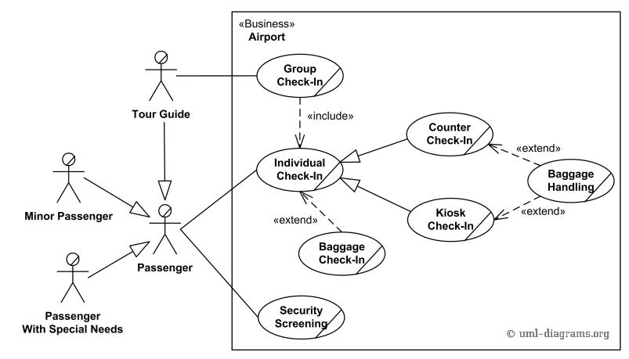

1. Restaurant business model

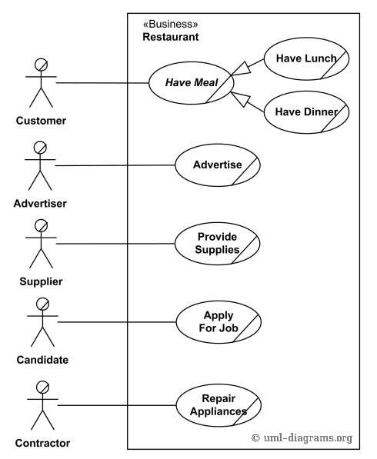

1. Ticket vending machine

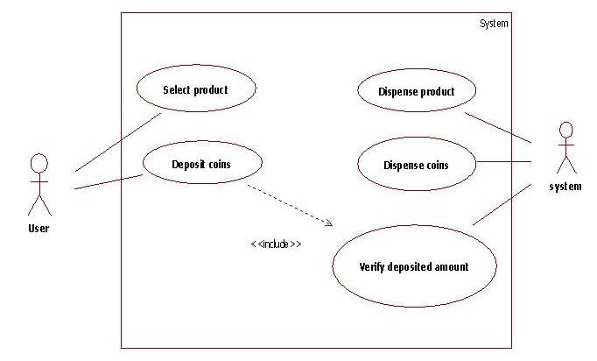

4. Bank ATM UML use case diagrams examples

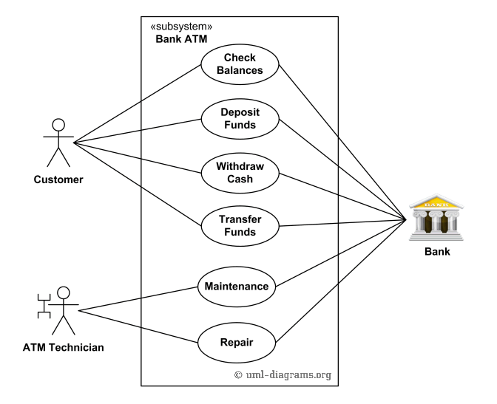

1. Point of sales (POS) terminal

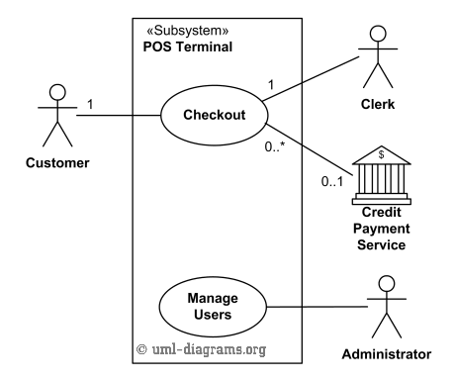

6. E-Library online public access catalog (OPAC)

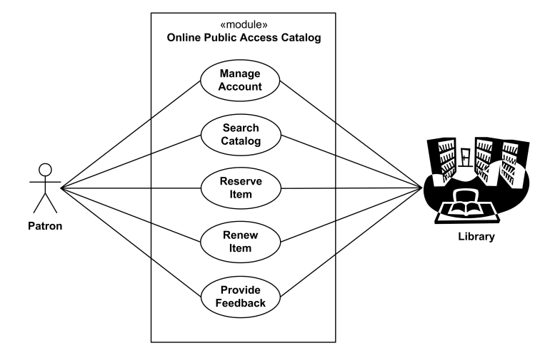

7. Online shopping use case diagrams

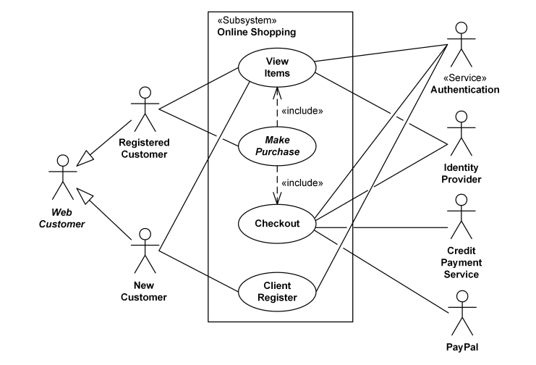

8. Hospital Management

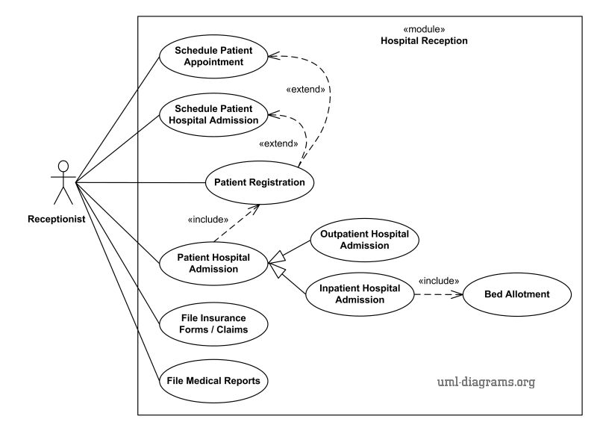

10. Radiology diagnostic reporting UML use case diagram

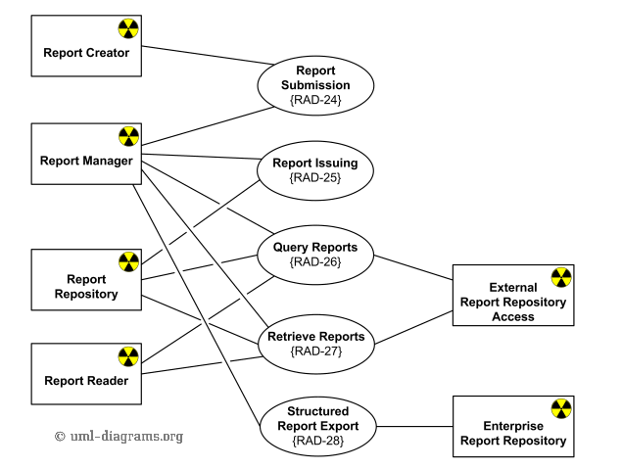

1. Design a UML diagram for a centralized hotel reservation system which is working online, hotel desktop application and a customized application for travel agents.

